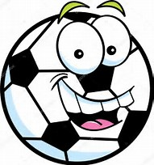
2017-18 Winter YOUTH SPORTS
Member: $15.00 Non Member: $34.50 6 week sessions
*Free with A Family Membership*
YMCA of Corry; 906 N.Center St; 814-664-7757

AGES 3-5 | AGES 6-12
Kinder Ninja* Monday @ 3:15 -3:45PM  Take part in the first -ever obstacle inspired kinder class. Tumbling, jumping, and overcoming obstacles will be instructed during this course. | Little Lawn League* Monday@ 4:00PM - 4:45PM  Just because winter is coming doesn’t mean that summer games have to end! Our newest class is introducing Cornhole, KanJam and Ladder toss so you can enjoy summer all year round!
Little Rookies* Tuesday @ 3:15PM - 3:45PM  Each week participants will be presented with a new sport and a new skill to learn. A great class to prepare your child for sports as they get older! | Gym Jam* Tuesday@ 4:00PM - 4:45PM  Gym Jam will introduce participants to classic gym games (Speed ball, Cone ball, Rossball etc.)! Leadership and good sportsmanship will be emphasized!
Jacks and Crafts* Wednesday@ 3:15PM-3:45PM  One of our most popular classes, Jacks and Crafts is a great way for your child to express their artistic abilities. Each week a new craft is made! | Crafty Kids* Wednesday@ 4:00PM - 4:45PM  An older version of jacks and crafts, crafty kids allows participants to use their artistic abilities in a fun instructor led setting!
Little Builders* Thursday @ 3:15-3:45PM  Perfect for the children who aren’t sports fanatics. Each week we will use our creativity to make new building block creations! | Nerf Wars* Thursday @ 4:00PM-4:45PM  Making a return to the YMCA is our NERF WARS. Come on in and join us in some epic battles!
Balloon Bash* Friday @ 3:15PM - 3:45PM  Come participate in our new balloon based class that will be focused on improving hand eye coordination! Different games will be played and new skills will be taught weekly. *We will be using Latex Balloons* | Floor Hockey* Friday @ 4:00PM -4:45PM  This introduction to hockey basics will have your son or daughter learn sport fundamentals including stick handling, passing, shooting, positions and teamwork.
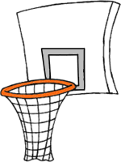
Winter I: Nov. 20th – Dec. 31st Winter II: Jan. 1st- Feb. 11th Winter III: Feb. 12th – March 25th
