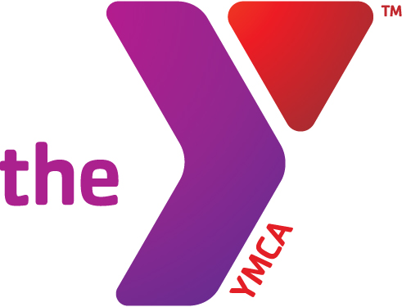



**Swim Team News**

Home Swim Meet Schedule

Jan 13, 27 *Feb 17 home invitational

Pool will be closed at 10 am for meets- FREE entry. Please support the team’s concession stand!

**Diving returns in the spring**

Tuesday/Thursday

4:00-4:45pm

Members: $33.00 Non Members: $72.00

**Youth Swim Lessons**

Monday/Wednesday

3:30-4:15pm

Tuesday/Thursday

4:00-4:45pm

Members: $33.00 Non Members: $72.00

Saturday 9:00-9:45am

Members: $16.50 Non Members: $36.00

**Preschool Swim Lessons**

All classes have 15 mins exploration time

Monday/Wednesday

3:30-4:15pm

Tuesday/Thursday

4:00-4:45pm

Members: $33.00 Non Members: $72.00

Saturday 9:00-9:30am

Members: $16.50 Non Members: $36.00

Members: $15.00 Non Members: $34.50

**Parent Child Classes** (**1 day/week)**

Saturday 9:30-10:00am

Members: $16.50 Non Members: $36.00

Fall Youth Aquatic Programs

operate in 6-week sessions.

Winter 2 January 2- February 10

Winter 3 February 12-March 24

***Parent observation days are always held on the last swim class of the 6 week session.***

**Open Swim Schedule Free to Members**

Tuesday/Thursday 3:30-4:00

**\*\*Pool Pass Fridays\*\***

**$2.00 community members**

Friday 7-8:30pm

Saturday 10:00-2pm * See swim team schedule for Saturday closures

Watch for special open swims on No School Days

**FREE Youth Swim Lessons**

If you are in need of assistance to provide your son or daughter the opportunity to participate in our Youth Swim Lesson Program, please contact Lisa Cox at [lisa_ymca@hotmail.com](mailto:lisa_ymca@hotmail.com). Due to the generosity of : The Corry Central Labor Club, the VFW, Rotary Club of Corry, The American Legion and many private donors we are able to provide assistance if needed. “Swim Lessons Save Lives Campaign 2018”

**Birthday Parties at the Y Pool**

Enjoy your birthday at the Y. Parties held on Saturdays anytime from 12-4 and Sundays 12:30-3. Parties can use our party room, pool and gymnasium. The room is set up with tables and chairs and we do all the CLEAN UP! You can decorate if you choose. There are refrigerators and electric outlets available for use.

We give you the space and you make the FUN!

Members $95 Non-members $110.00

**Deepwaterobics**

Tuesday/Thursday

9:30-10:30am

Members: Free Non Members: $5.00

**Aquarobics (Shallow Water)**

Monday/Wednesday/Friday

9:30-10:30am

Members: Free Non Members: $5.00

**Lap Swim**

Mon/Wed/Fri 5:30-7:30am, T/Thr 5:30-7:00am

Mon-Fri 11:30a-12:30p

Saturday 8-9am

Also available during any open swim