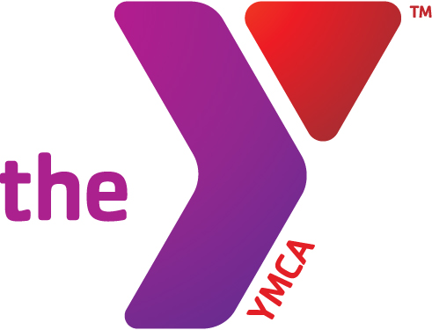



**Preschool Swim Lessons**

All classes have 15 mins exploration time

Monday/Wednesday 5:15-6pm (fall1only)

3:30-4:15pm

Tuesday/Thursday

4:00-4:45pm

Members: $33.00 Non Members: $72.00

Saturday 9:00-9:30am

Members: $16.50 Non Members: $36.00

Members: $15.00 Non Members: $34.50

**Parent Child Classes** (**1 day/week)**

Monday 5:30-6pm Fall 1 only

Saturday 9:30-10:00am

Members: $16.50 Non Members: $36.00

Fall Youth Aquatic Programs

operate in 6-week sessions.

Fall 1 August 28- October 7

Fall 2 October 9-November 17

***Parent observation days are always held on the last swim class of the 6 week session.***

**Open Swim Schedule Free to Members**

Monday/Wednesday 4:15-5:15pm till Sept 19

Tuesday/Thursday 3:30-4:00/ 4:45-6pm-Sept 30

Tuesday/Thursday 3:30-4pm after Sept 20

**\*\*Pool Pass Fridays\*\***

**$2.00 community members**

Friday 3:30-7:00pm till Sept 15

3:30-4:30pm & 6-7:00pm after Sept 22

Saturday 10:00-2pm

**New***Aqua Boot Camp\*\*\***

Monday & Wednesday 5-5:45pm

Give your body a WAKE UP call by trying this intense “Boot Camp” style water work out. Where gym clothes, swim suit or tight fitting shorts/shirt. Participants will move between drylands and water movements.

Flotation can be worn if needed. Drill Sargent Amy, Danielle & Anna will put your body to the test.

Members: FREE Non Members: $5.00

**Birthday Parties at the Y Pool**

Enjoy your birthday at the Y. Parties held on Saturdays anytime from 12-4 and Sundays 12:30-3. Parties can use our party room, pool and gymnasium. The room is set up with tables and chairs and we do all the CLEAN UP! You can decorate if you choose. Refrigerators and electric outlets available for use.

We give you the space and you make the FUN!

Members $95 Non-members $110.00

**Deepwaterobics**

Tuesday/Thursday

9:30-10:30am

Members: Free Non Members: $5.00

**Aquarobics (Shallow Water)**

Monday/Wednesday/Friday

9:30-10:30am

Members: Free Non Members: $5.00

**Lap Swim**

Mon/Wed/Fri 5:30-7:30am, T/Thr 5:30-7:00am

Mon-Fri 11:30a-12:30p

Saturday 8-9am

Also available during any open swim

**Youth Swim Lessons**

Monday/Wednesday

3:30-4:15pm

Tuesday/Thursday

4:00-4:45pm

Members: $33.00 Non Members: $72.00

Saturday 9:00-9:45am

Members: $16.50 Non Members: $36.00

**Diving Fall 1 only**

Tuesday/Thursday

4:00-4:45pm

Members: $33.00 Non Members: $72.00

**Swim Team News**

FREE Trial Monday Sept 19-Sept 29

Monday-Thursday 6-8pm Friday 4:30-6pm

Kids age 6-18 No Try-outs EVERYONE SWIMS! Team starts Oct 2

Call Lisa at 664-7757 for questions